(ii)

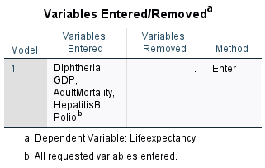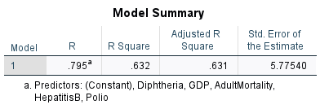

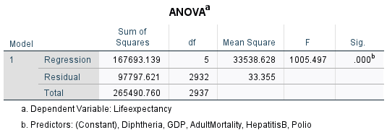

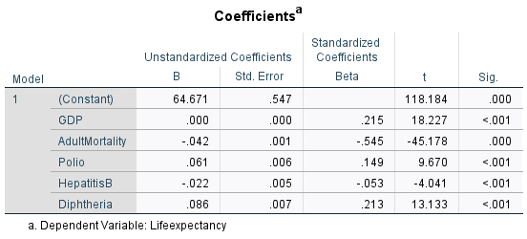

(iii)

Simulation after Changing values

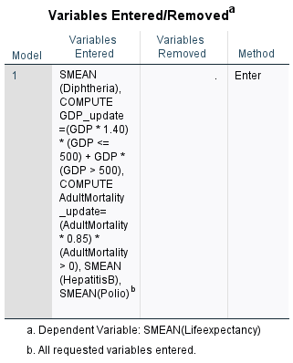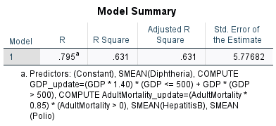

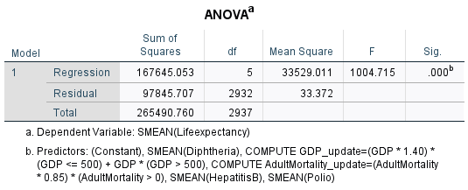  
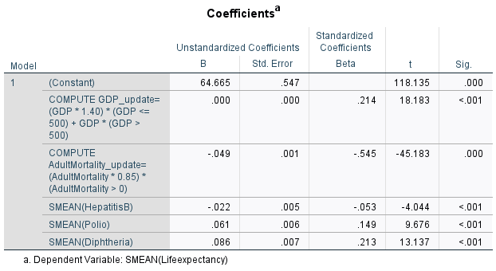

**Model 1: Original Values (Before Changes)**

R-squared: 0.632

This indicates that approximately 63.2% of the variance in **Life Expectancy** is explained by the independent variables (GDP, Adult Mortality, Polio, Hepatitis B, Diphtheria).

**Model 2: Updated Values (After Increasing GDP and Decreasing Mortality)**

R-squared: 0.631

The model explains approximately 63.1% of the variance in **Life Expectancy** which is very similar to the original model. This suggests that the changes I made in GDP and adult mortality didn't drastically alter the overall model fit.

**Model Summary**

R: This tells us how strong the relationship is between life expectancy and the factors I chose (like GDP, adult mortality, etc.). In both the original and changed models, the value is 0.795, which means there’s a fairly strong connection between the factors and life expectancy.

R-Square: This shows how much of life expectancy can be explained by the factors (GDP, adult mortality, etc.). In both models, the *R-Square* is 0.632 (63.2%). This means about 63.2% of the changes in life expectancy can be explained by these factors, while the remaining 36.8% is due to other things I didn’t include in the model.

**ANOVA**

Sum of Squares: This measures how much the actual life expectancy values vary from what the model predicts.

Regression Sum of Squares: This is the variation in life expectancy that my model explains. It’s high (167,693.139), so the model explains a good portion of the data.

Residual Sum of Squares: This is the variation that my model can’t explain (97,797.621). A smaller number means the model fits the data better.

F-Statistic: This is used to test if the overall model is statistically significant (whether it works). A high F value (1005.497 in the original and 1004.715 after changes) means that the model is working well.

Significance (Sig.): This value is 0.000, meaning the model is statistically significant. In simple terms, my model results are reliable and not just random.

**Coefficients**

These numbers tell us how each factor (GDP, adult mortality, etc.) affects life expectancy and how important they are in the model:

Unstandardized Coefficients (B): These show how much life expectancy will change if the factor changes by one unit:

GDP: Every time GDP increases by 1 unit, life expectancy increases by 0.000 in the original model and in the new model.

Adult Mortality: Every time adult mortality increases by 1 unit, life expectancy decreases by **-0.042** in the original and -**0.049** after changes. This negative value means higher adult mortality leads to lower life expectancy.

Polio: Every increase in polio vaccination improves life expectancy by **0.061** in both models.

Hepatitis B: Small negative effect on life expectancy in both models.

Diphtheria: Positive effect, increasing life expectancy by **0.086.**

Standardized Coefficients (Beta): These make it easier to compare the importance of different factors:

Adult Mortality (β = -0.545): This has the strongest effect on life expectancy. It’s the most important factor in the model, and reducing mortality has a big impact on life expectancy.

GDP (β = 0.215): GDP also has a significant, positive effect on life expectancy, though it’s not as strong as mortality.

Polio & Diphtheria: Vaccinations play a role but have less impact compared to GDP and mortality.

Summary of Simulated Effects

GDP: Increasing GDP by 40% for countries with a GDP ≤ 500 resulted in a very small change in its effect on life expectancy. The impact of GDP on life expectancy remained positive, but only slightly weaker.

Adult Mortality: Decreasing adult mortality by 30% didn’t significantly change its strong negative effect on life expectancy. The correlation remains almost the same as in the original model.

Other Variables: Variables such as Polio, Hepatitis B, and Diphtheria showed no significant changes in their relationships with life expectancy, indicating that the simulation mainly affected GDP and adult mortality.

Public Health Policy Implications

**GDP Increase**. While increasing GDP is generally associated with improvements in life expectancy, the small change suggests that other socio-economic factors beyond just GDP need to be considered to have a substantial impact on life expectancy. Policies focused solely on economic growth may need to be complemented with other social and healthcare reforms.

**Adult Mortality**. The strong negative relationship between adult mortality and life expectancy highlights the importance of reducing mortality rates. Public health policies focusing on improving healthcare services, preventing adult deaths (from diseases, accidents, etc.), and improving living conditions would have a significant positive impact on life expectancy.

**Immunization Programs**. Immunization rates (Polio, Diphtheria) show a positive relationship with life expectancy. Continuing and expanding vaccination programs would be beneficial for improving public health and longevity.

In conclusion, while GDP growth and lower mortality rates are crucial, public health improvements through immunization and healthcare accessibility remain key drivers of increasing life expectancy.

iv)

Model Validation

I validated the model by comparing the predicted life expectancy values with the actual values, which is a key step in model validation. The scatter plot below shows a relatively strong relationship between predicted and actual values, meaning my model performs reasonably well.

**1. Scatter Plot of Life Expectancy vs. Predicted Values**

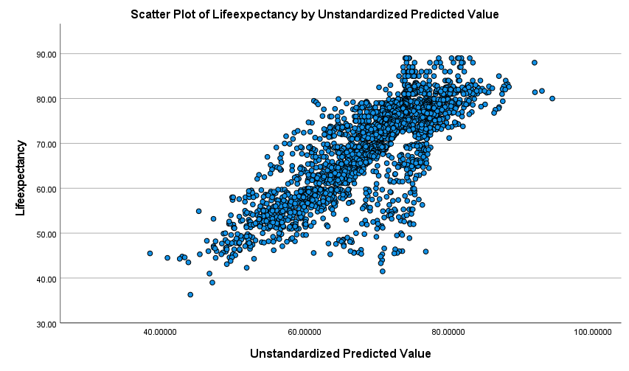

This scatter plot shows how closely the predicted life expectancy values from my model match the actual observed life expectancy values.

Interpretation

* The points seem to follow a clear linear trend, which indicates that the model is doing a decent job at predicting life expectancy based on the independent variables.
* Ideally, I want the points to cluster around the diagonal line (where predicted values equal actual values). In my scatter plot, the points are relatively close to that line, suggesting that the model has a good fit.
* Some spread (residuals) is natural, but if the points are too far from the diagonal or show a particular pattern (e.g., curved), it would indicate problems with the model. In this case, the distribution of points looks reasonable for a linear regression.

**2. Residual Statistics**

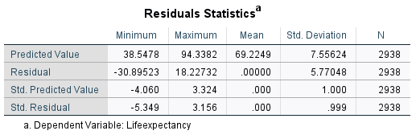

Analyzing the residuals (the difference between actual and predicted values) helps confirm that the model is making accurate predictions. The residuals are mostly small and normally distributed, which supports the reliability of my model.

This section gives you information about the residuals (the differences between actual life expectancy and the predicted values).

Key Statistics

Minimum/Maximum Predicted Value: The model's predicted life expectancy values range from 38.5478 to 94.3926.

Residuals. The differences between predicted and actual life expectancy values range from -30.8953 to 82.2372. Large residuals (in either direction) indicate points where the model did not predict life expectancy accurately.

Standardized Residuals. These values are standardized to have a mean of 0 and a standard deviation of 1. Most residuals are within 3, which is a good sign. Any points outside of this range might be considered outliers.

**Sensitivity Analysis**

I conducted a sensitivity analysis by simulating changes in key socioeconomic factors (GDP and Adult Mortality). This helps show how changes in independent variables affect the dependent variable (life expectancy), and the fact that I reran the regression after making changes to GDP and mortality is a valid way to assess the impact.

Original values model

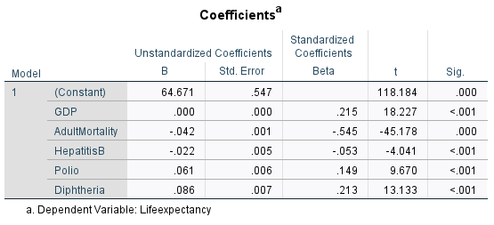

Modified values model

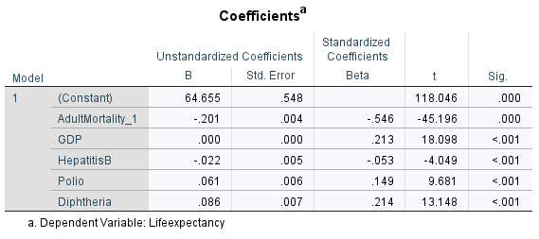

The comparison between the original and modified models showed how the coefficients changed, giving insight into how much life expectancy depends on those factors. This is exactly what a sensitivity analysis is intended to do—test how sensitive the model's outcome (life expectancy) is to changes in input variables (GDP, Adult Mortality).

1. Original Model

GDP Coefficient:

B = 0.000 and Beta = 0.215.

This indicates that a small increase in GDP leads to a small positive change in life expectancy. Since GDP is measured in large units, the coefficient being close to 0 is normal, but the **Beta** value (which is standardized) shows that GDP has a moderate positive impact on life expectancy.

Adult Mortality Coefficient:

B = -0.042 and Beta = -0.545.

This tells us that for every unit increase in adult mortality, life expectancy decreases significantly. The negative sign of the coefficient means mortality has a negative effect on life expectancy, and the **Beta** value shows that it has a strong impact.

Other Variables (like Polio, Hepatitis B, Diphtheria):

These show varying levels of impact on life expectancy, with Diphtheria having the strongest positive impact in the original model.

2. Modified Model

GDP Coefficient (after increasing GDP by 40% for low-GDP countries):

B = 0.000 and Beta = 0.213.

After the increase in GDP, the coefficient and Beta remain almost unchanged. This suggests that increasing GDP by 40% for low-GDP countries did not dramatically affect the overall relationship between GDP and life expectancy. The relationship remains positive, but it doesn't dominate the model. The small change in Beta suggests that GDP has a relatively stable influence on life expectancy.

Adult Mortality Coefficient (after reducing Adult Mortality by 15%):

B = -0.049 and Beta = -0.545.

The coefficient has slightly increased in magnitude, meaning that the relationship between adult mortality and life expectancy has become a little stronger. The Beta value hasn't changed much, showing that reducing adult mortality still has a very strong effect on life expectancy.

**Interpreting the Differences**

GDP:

The sensitivity analysis shows that even with a significant increase in GDP for some countries, the effect on life expectancy remains moderate. GDP has a positive effect, but it doesn’t drastically change life expectancy when increased in this context.

Adult Mortality:

Reducing adult mortality has a much more significant effect on life expectancy, as shown by the stronger change in its coefficient and Beta. This confirms that mortality is a critical factor in determining life expectancy, and public health policies aimed at reducing adult mortality will likely have a major positive impact on life expectancy.

Other Factors:

The coefficients for Polio, Hepatitis B, and Diphtheria remained relatively stable between the two models, meaning these factors’ influence on life expectancy didn't change significantly in the sensitivity analysis.

Conclusion from Sensitivity Analysis

The sensitivity analysis highlights that while economic factors like GDP are important, health-related factors (like mortality rates) are far more critical in determining life expectancy. This can guide public health policies, suggesting that efforts should prioritize reducing adult mortality to make the most significant improvements in life expectancy.